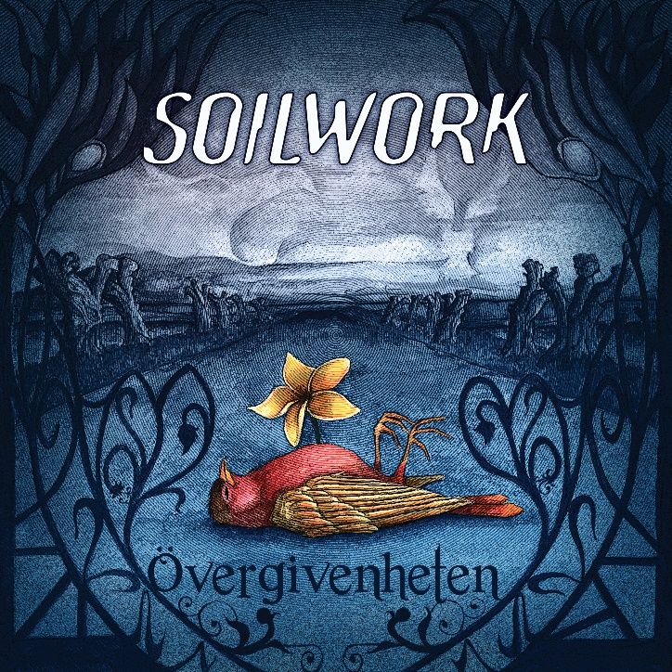

SOILWORK

»Övergivenheten«

OUT: August 19th, 2022

Lineup: | SOILWORK online:
Björn “Speed” Strid | Vocals  David Andersson | Guitar  Sylvain Coudret | Guitar  Bastian Thusgaard | Drums  Sven Karlsson | Keys  Rasmus Ehrnborn | Bass | www.facebook.com/soilwork  www.instagram.com/soilwork  www.twitter.com/soilwork www.soilwork.org  www.nuclearblast.de/soilwork

SOILWORK is back with their twelfth studio album, which represents the band in their growth and their current phase of life, which is marked by a time period that probably no one on this planet will forget so quickly.

Unlike the albums before, the creation process of Övergivenheten was very lengthy and a representation of the emotional state of the guys from SOILWORK. Recorded at Nordic Sound Lab in Skara, Sweden again with producer Thomas “Plec” Johansson, who also produced the last two projects, the album was written and recorded over three sessions between January and December 2021. There was no hurry to finish the album, which meant on the other side that the band was able to reflect on their music and savor the process of creating the album.

Musically, Övergivenheten is the continuation of the SOILWORK legacy of the last years. The approach is to make the album sound as organic as possible. Therefore, among other things, acoustic elements have been incorporated into the songs, which help to make the sound experience as close and genuine as possible. The album is intended to give the feeling of being in the middle of creating the energy and feeling the atmosphere. To build this experience and, above all, to give the listener the feeling of being right in the center of the band’s creative environment, balance was needed, something that the external circumstances made difficult, especially due to the current situation in the world.
Not being able to do what every band loves to do, playing live for their fans, and being trapped in an inner circle, has turned out to be more difficult than expected. The pandemic influenced the band in more than one way. However, concerning the album it has also been an inspiration. Each band member perceived the last two years differently in terms of boundaries and personal development. All the surroundings, which appeared, influenced the creation of the album.

This taken inspiration of each band member can be heard clearly on the new songs. Singer Björn “Speed” Strid has developed lyrically and speaks not only about his personal perception and about experience, but on Övergivenheten, he refers much more to his environment by reflecting the outside including external impressions.

Övergivenheten can be translated to The Abandonment, which describes the overall album theme. To be surrounded by the thought of being abandoned or even abandoning others. The album deals with darker thoughts that have shaped the band itself and affected the development process of the album. The personal struggles align with social difficulties outside of the band.

Due to the pandemic, everyone has had their tail cut off, and a lot of negative energy in the immediate environment makes it difficult to block this out and create new music around cheerful themes. Guitarist David Andersson's songwriting has been largely influenced by dark thoughts used as an escape to deal with difficulties that are directly related to midway anxiety, which also resonates with the lyrics he wrote. In terms of balancing the darkness of David’s lyrics out, Björn takes own inspiration with his point of view. Since both connect an intense relationship which lasts multiple years, music is the common language that brings both of them on the same level despite their different stages of life. This can be recognized on Övergivenheten.

SOILWORK are looking forward to the best post pandemic possible. It is planned to play several festivals and additional tour dates to support the album. Since it is finally possible to return on the streets, the excitement is already there. Drummer Bastian Thusgaard comments on going back on the road: “We don’t know what to expect when getting back out there. It is kind of abstract to return to touring lifestyle due to the long break and uncertainty, but we are looking forward to the return.” Also looking forward to the tour is freshly announced fulltime bassist Rasmus Ehrnborn who records with the band already since the EP “AWOTA”. His fresh blood adds a new dimension to the band whose line-up is completed by long-time keyboardist Sven Karlsson and guitarist Sylvain Coudret besides of David, Björn and Bastian.

Anyway, SOILWORK will not flinch, continuing to give free rein to their creativity. On the one hand to share and process their personal experiences and on the other hand to serve their fans. Everyone needs creativity and art in life, and no matter what happens SOILWORK will not stand still but give their fans what they want: honest music by trying to create a snapshot in time!

